CYNGOR CYMUNED LLANISMEL
ST ISHMAEL COMMUNITY COUNCIL

ADRODDIAD FLYNYDDOL 2025-26
ANNUAL REPORT 2025-26

Written on behalf of St Ishmael Community Council
By Julie Rees, Clerk

Contents
- Council Members and responsibilities
- Council Meetings
- Financial Accounts and Support
- Council Services Provided
- Community Activity
- Plans for 2026-27

Council Members and Responsibilities
During the 2025-26 year the St Ishmael Community Council Members were:
Name | Additional responsibilities | Ward
Cllr Paul Stephens | Chair  FSEG Representative  Bank signatory | Ferryside
Cllr Janae Holliday | Vice – Chair  One Voice Wales Representative | Ferryside
Cllr Alicia Dalton | Bank signatory  Llansaint Welfare Hall Representative  Governor – Ysgol Glan Y Fferi | Llansaint
Cllr Jeff Batte | Burial Authority Chair  TfW Station Adoption Scheme representative  Bank signatory | Ferryside
Cllr Hywel Gibbon | Bank signatory | Llansaint
Cllr Peter Thomas |  | Picton
Cllr Scott Wyld |  | Ferryside
Cllr Davinia King | Ferryside Village Hall Representative | Ferryside
Cllr Lena Siddall |  | Ferryside
Cllr Phillip George |  | Ferryside
Cllr Keith Harding |  | Picton
Cllr Dawn Afzal |  | Llansaint
Please note that a list of the current members can be found on the website.
Council Staff
- Julie Rees, Clerk and Responsible Finance Officer to St Ishmael Community Council since December 2019.
- Michael Leefe, Community Council handyperson since February 2023.

Council Meetings 2025-26
Council Meetings are generally held on the first Tuesday of the month and alternate between Llansaint Welfare Hall and Ferryside Village Hall. Meetings are held monthly between September – July. Members of the public are welcome to attend meetings to discuss any issue on the Agenda. Agendas are published prior to the meetings on the website www.stishmaelscc.org.uk and on the local noticeboards.
Council Meeting were held as follows in 2025-26:
Date | Location
1st April 2025 | Ferryside Village Hall
13th May 2025 | Llansaint Welfare Hall
10th June 2025 | Ferryside Village Hall
8th July 2025 | Ferryside Village Hall
2nd September 2025 | LLansaint Village Hall
7th October 2025 | Ferryside Village Hall
11th November 2025 | Llansaint Welfare Hall
2nd December 2025 | Ferryside Village Hall
13th January 2026 | Llansaint Welfare Hall
3rd February 2026 | Ferryside Village Hall
3rd March 2026 | Llansaint Welfare Hall (conference room)

Additional Meetings took place:
Type | Date | Location
Burial Authority | 14th April 2025 | Ferryside Village Hall
Burial Authority | 20th October 2025 | Ferryside Village Hall

Draft Financial Accounts are as follows for the 2025-26 year. The accounts have been subject to an internal audit.
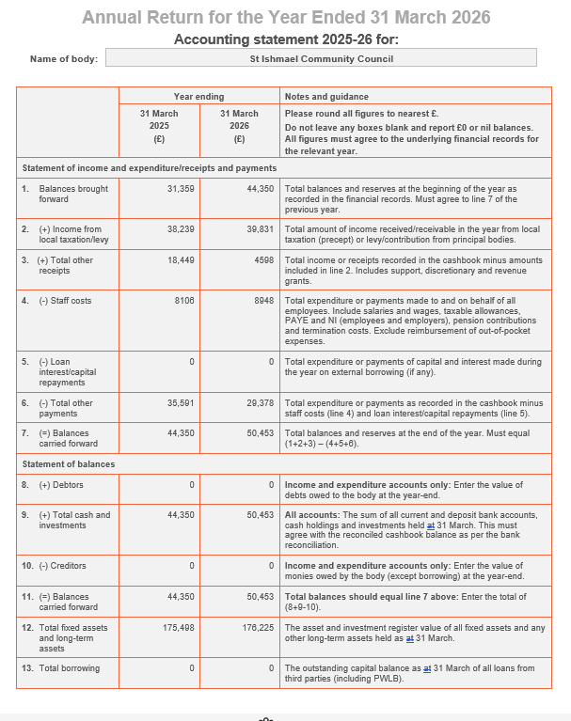

During the year financial support was given to the following organisations:
Organisation | Amount
Marie Curie Great Daffodil Appeal | £25.00
CCC Toy Box Appeal | £100.00
Ferryside After School Club | £100.00
Ferryside VCP School PTA – swimming lesson transport | £900.00
PBP Foodbank | £100.00
Ferryside RFC – fireworks display | £500.00
Wales Air Ambulance | £200.00
Llansaint Village Hall Grant and Grass Cutting contribution | £1000.00

Community Council Services Provided

- Ferryside Play Area
- MUGA (Multi Use Games Area)
- Salem Cemetery – grass cutting and maintenance
- Pale Field – grass cutting and maintenance
- Amenity Area at Ferryside Beach foreshore
- Three corners and Fisherman Statue at Ferryside Square
- Various community benches
- Community planters
- Hanging baskets
- Bus Shelters in Glan Tywi and Llansaint
- Grass cutting of the verge opposite the Pale Field / Calon Y Fferi
- Provision of footway and roadside lighting
- 6 Community AED’s
- Several heritage information signs
- Provision of financial donations to community and charitable organisations
- Nominated members for Llansaint Welfare Hall, Ferryside Village Hall, Ferryside Social Enterprise Group and a Governor for Ysgol Glan Y Fferi.
- Christmas trees and lights for Llansaint and Ferryside.

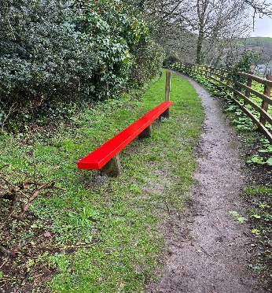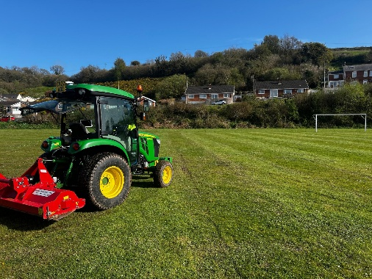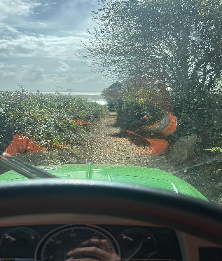

Community Activity
VE day celebrations – were held in Llansaint Welfare Hall to mark 80th Anniversary. The Community Council provided a beacon, refreshments were provided by Llansaint Welfare Hall and a service was held by the local minister.
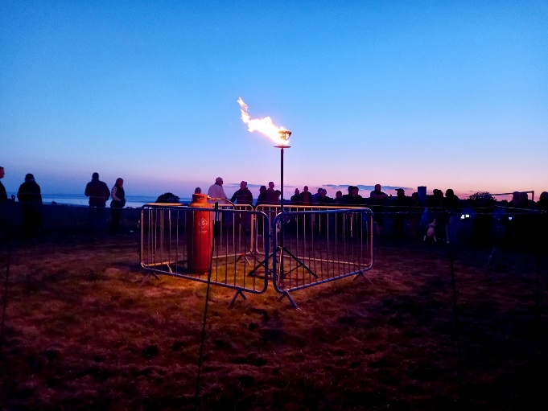

Christmas Lights – The community council worked with Llansaint Welfare Hall, St Thomas’ Church and local businesses to hold Christmas Services by providing trees and lights in both Ferryside and Llansaint.
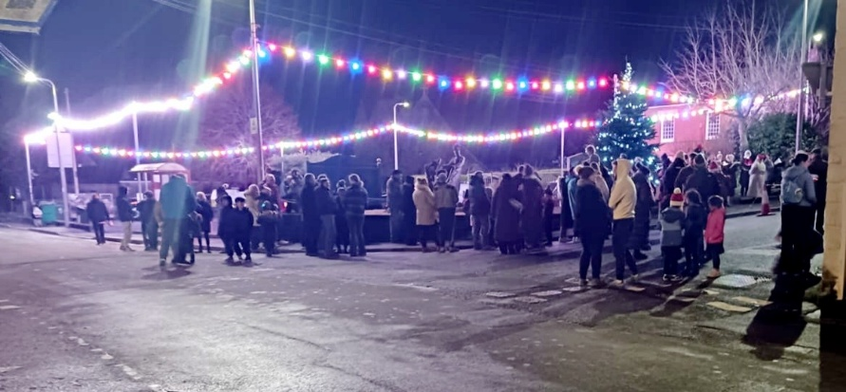

Improvements to the Llansaint planters – one new planter has been added on Llansaint Square with new plants added to a second planter to provide some summer colour.

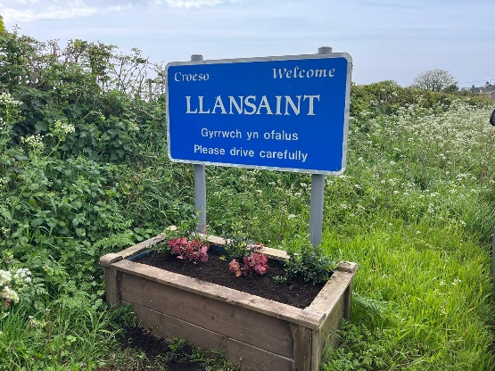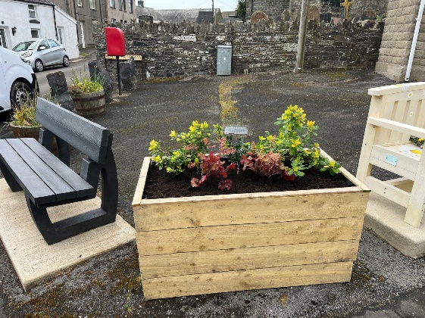

Improvements to Pale Field – The Community Council met with a One Voice Wales biodiversity officer to discuss improvements that could be made on the Pale Field. One of the many things recommended was to mulch 40+ saplings to ensure they develop more effectively.

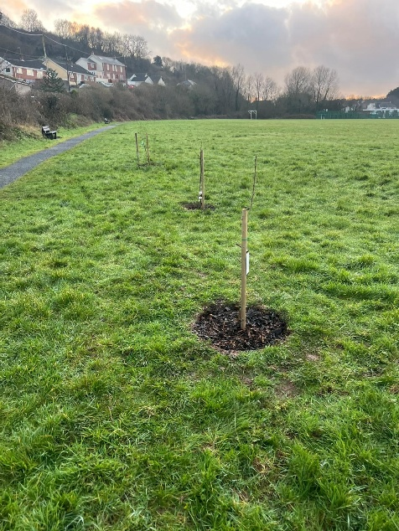

Ferryside Play Area – Replacement of the baby swing.
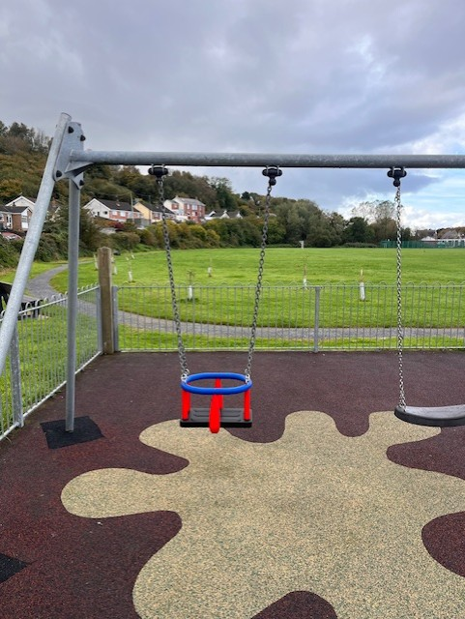

Improvements to Salem Cemetery
The Community Council took over Salem Cemetery in March 2025 and have begun to make some positive improvements by adding additional handrails, grass cutting 6-8 times a year, regular weeding, clearing pathways and painting the main gates.

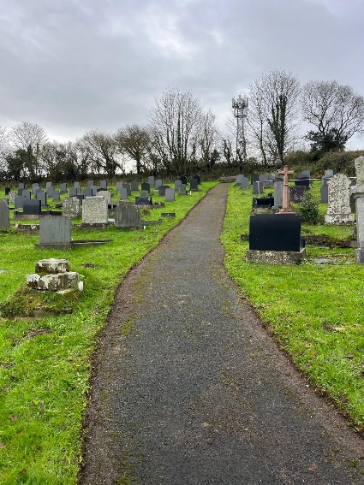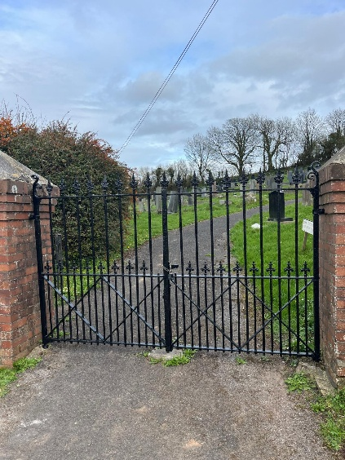

Plans for 2026-27
During the 2026-27 year the Community Council will continue to seek opportunities and work with its partners to support improvements to our community and to develop our services and facilities while maintaining those already in place on behalf of the community.
The Community Council also hopes to achieve the following:
- To begin replacing the oldest defibrillators.
- Provide further improvements at Salem Cemetery.
- Provide continued improvements on Ferryside Square (School Corner)
- To work towards further improvements on the Pale Field.

