**CYNGOR CYMUNED LLANISMEL**

**ST ISHMAEL COMMUNITY COUNCIL**



ADRODDIAD FLYNYDDOL 2024-25

ANNUAL REPORT 2024-25

Written on behalf of St Ishmael Community Council

By Julie Rees, Clerk

**Contents**

1. Council Members and responsibilities
2. Council Meetings
3. Financial Accounts and Support
4. Council Services Provided
5. Community Activity
6. Plans for 2024-25

**Council Members and Responsibilities**

During the 2024-25 year the St Ishmael Community Council Members were:

|  |  |  |
| --- | --- | --- |
| **Name** | **Additional responsibilities** | **Ward** |
| Cllr Paul Stephens | Chair  FSEG Representative  Bank signatory | Ferryside |
| Cllr Janae Holliday | Vice – Chair  One Voice Wales Representative | Ferryside |
| Cllr Alicia Dalton | Bank signatory  Llansaint Welfare Hall Representative  Governor – Ysgol Glan Y Fferi | Llansaint |
| Cllr Jeff Batte | TfW Station Adoption Scheme representative  Bank signatory | Ferryside |
| Cllr Hywel Gibbon | Bank signatory | Llansaint |
| Cllr Mike Jones | TfW Station Adoption Scheme representative  Bank signatory  Resigned during the year | Ferryside |
| Cllr Peter Thomas |  | Picton |
| Cllr Scott Wyld |  | Ferryside |
| Cllr Davinia King | Ferryside Village Hall Representative | Ferryside |
| Cllr Lena Siddall |  | Ferryside |
| Cllr Phillip George |  | Ferryside |

Please note that a list of the current members can be found on the website.

**Council Staff**

* Julie Rees, Clerk and Responsible Finance Officer to St Ishmael Community Council since December 2019.
* Michael Leefe, Community Council handyperson since February 2023.

**Council Meetings 2024-25**

Council Meetings are generally held on the first Tuesday of the month and alternate between Llansaint Welfare Hall and Ferryside Village Hall. Meetings are held monthly between September – July. Members of the public are welcome to attend meetings to discuss any issue on the Agenda. Agendas are published prior to the meetings on the website [www.stishmaelscc.org.uk](http://www.stishmaelscc.org.uk) and on the local noticeboards.

Council Meeting were held as follows in 2024-25:

|  |  |
| --- | --- |
| **Date** | **Location** |
| 9th April 2024 | Ferryside Village Hall |
| 14th May 2024 | Llansaint Welfare Hall |
| 4th June 2024 | Ferryside Village Hall |
| 9th July 2024 | Llansaint Welfare Hall |
| 3rd September 2024 | Ferryside Village Hall |
| 1st October 2024 | Llansaint Welfare Hall |
| 12th November 2024 | Ferryside Village Hall |
| 3rd December 2024 | Llansaint Welfare Hall |
| 7th January 2025 | Ferryside Village Hall |
| 4th February 2025 | Ferryside Village Hall |
| 4th March 2025 | Ferryside Village Hall |

Additional Meetings took place:

|  |  |  |
| --- | --- | --- |
| **Type** | **Date** | **Location** |
| Extraordinary Meeting – Salem Cemetery | 23/04/24 | Ferryside Village Hall |
| Extraordinary Meeting: Planning Consultation PL/08229 | 28/09/24 | Ferryside Village Hall |

Draft Financial Accounts are as follows for the 2024-25 year. The accounts have been subject to an internal audit.

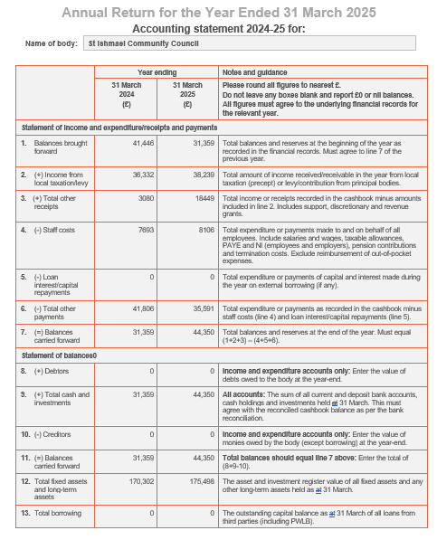

During the year financial support was given to the following organisations:

|  |  |
| --- | --- |
| **Organisation** | **Amount** |
| Cylch Meithrin Glan Y Fferi | £500.00 |
| Llangollen International Musical Eisteddfod | £50.00 |
| Ferryside Social Enterprise Group | £2500.00 |
| Ferryside VCP School – swimming lesson transport | £832.50 |
| Ferryside AFC | £160.00 |
| Ferryside RFC – fireworks display | £500.00 |
| Wales Air Ambulance | £250.00 |
| Ferryside Village Hall Grant | £750.00 |
| Llansaint Village Hall Grant and Grass Cutting contribution | £1000.00 |

**Community Council Services Provided**

* Ferryside Play Area
* MUGA (Multi Use Games Area)
* Salem Cemetery
* Pale Field – grass cutting and maintenance
* Amenity Area at Ferryside Beach foreshore
* Three corners and Fisherman Statue at Ferryside Square
* Various community benches
* Community planters
* Bus Shelters in Glan Tywi and Llansaint
* Grass cutting of the verge opposite the Pale Field / Calon Y Fferi
* Provision of footway and roadside lighting
* 7 Community AED’s
* Several heritage information signs
* Provision of financial donations to community and charitable organisations
* Nominated members for Llansaint Welfare Hall, Ferryside Village Hall, Ferryside Social Enterprise Group and a Governor for Ysgol Glan Y Fferi.
* Christmas trees and lights for Llansaint and Ferryside.

**Community Activity**

**D-day celebrations** – were held in Llansaint to mark the 80th anniversary of D-day. The Community Council provided a beacon and a service was held by the local ministers.

**Christmas Lights** – The community council worked with local community groups and residents to hold Christmas Services by providing trees and lights in both Ferryside and Llansaint.

**Improvements to Pale Field (nr Play Area) –** The Community Council working with Keep Wales Tidy were able to provide two new benches, 15 fruit trees, a bug hotel, hedgehog house and over 200 bulbs. The trees and bulbs were planted alongside local volunteers and Ysgol Glan Y Fferi.

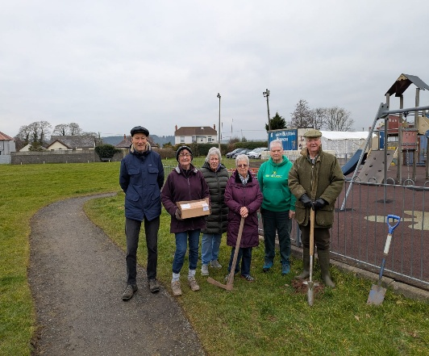

**Hanging Baskets on the Square in Ferryside** – Six hanging baskets were provided around the Car Park in Ferryside Square.

**Plans for 2025-26**

During the 2025-26 year the Community Council will continue to seek opportunities and work with its partners to support improvements to our community and to develop our services and facilities while maintaining those already in place on behalf of the community.

The Community Council also hopes to achieve the following:

* Provide a beacon to mark the anniversary of VE-Day.
* Provide improvements at Salem Cemetery.
* Provide improvements on Ferryside Square (School Corner)