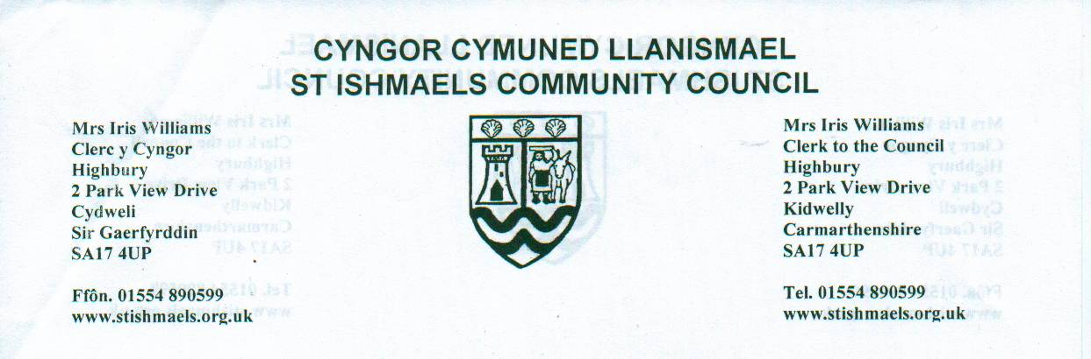

Details of the Celebration of the Platinum Jubilee of
Her Majesty the Queen from Thursday 2nd June to Sunday 5th June.
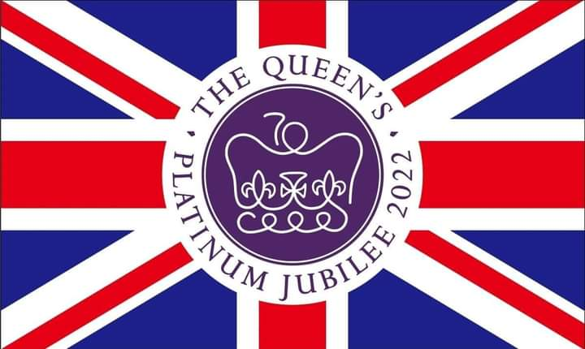
🏠 Best Dressed House Competition – The Community Council invite you all to dress your house before the 2nd June 2022. Prizes to be won.
🎨 Art Competition – Theme: Platinum Jubilee
Categories: Under 5’s
5 – 7 year olds
8 – 11 year olds
12 – 15 year olds
16+
All entries to be submitted 27th May 2022.

🏅 Platinum Jubilee Medals – The Community Council would like to award all children (and babies) 11 or under with medals.
Criteria for receiving a medal:
- You live in the St Ishmael Ward
- Your child is 11 years old or under
Please email clerk@stishmaelscc.co.uk with your child/ren’s name, date of birth and address before the 6th May 2022. If the information is not received by the deadline, no medal will be awarded. Letters will be going to the children of Ferryside School after the Easter holidays (therefore there no need to email if your children attend Ferryside School).
Events:
Thursday, 2nd June – Lighting of the Beacon Event at Llansaint Welfare Hall from 7pm
Sunday, 5th June – Church Service at St Thomas’ Church, Ferryside at 10.45am
Picnic in the Park at the Rugby Field from 3-5pm
Please bring your own picnic. Drinks available from the Rugby Club and Village Forum Café.
If anyone would like to volunteer to help, please contact the Clerk on clerk@stishmaelscc.co.uk
This document will be updated as more things are confirmed.
Any queries please contact the Clerk on 07828003648

