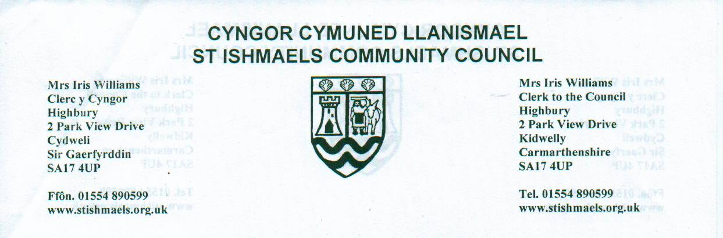

Final Arrangements of the Celebration of the Platinum Jubilee of
Her Majesty the Queen from Thursday 2nd June to Sunday 5th June.
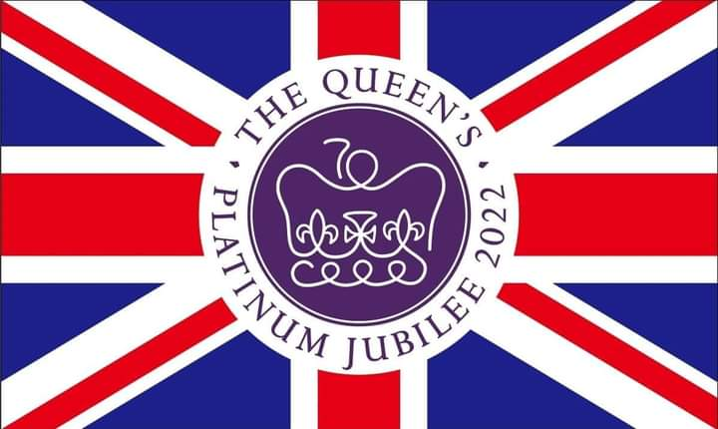
🏠 Best Dressed House Competition – The Community Council invite you all to dress your house before the 2nd June 2022. Prizes to be won. Winners will be announced at the Ferryside Village Hall on 3rd June.
🎨 Art Competition – The Community Council invite you to create some artwork themed “Platinum Jubilee”
Categories: Under 5’s, 5 – 7 year olds, 8 – 11 year olds, 12 – 15 year olds, 16+
Please ensure that your art is submitted by the 27th May and has your name, contact details and age category on the back. Ferryside Village Hall open between 5.30 – 7pm on the 26th May to submit entries. Llansaint Welfare Hall will be open between 6-7pm on 25th May to submit entries. Winners will be announced at Ferryside Village Hall on the 3rd June.

🏅 Platinum Jubilee Medals – The Community Council will award children 11 and under with medals, if registered before the 6th May. The medals will be presented to you at the events on the 2nd and 3rd June.
🎶 🎉 👑 Events:
Thursday, 2nd June – Street Party on the Field / Hall from 5pm and Old King’s Arms House Band from 7pm at Llansaint Welfare Hall. Please bring your own food for the Street Party, hot dogs will be available. Medals will be awarded to those that registered. Gather at Llansaint Square at 9:30pm for the lighting of the Church at 9:45pm.
Free Minibus leaving Glan Tywi Bus Stop from 6:30pm calling at Broadlay and Broadway (the minibus can be waved down on the way through the village). Return journey from 10pm.
Friday, 3rd June – Jubilee Tea Party hosted by Dorothy Morris at the Ferryside Village Hall 2-4pm. Medals will be awarded at 3pm for those that registered. Winners of the Art Competition and Best Dressed House Competition will also be announced.
Sunday, 5th June – Church Service at St Thomas’ Church, Ferryside at 10.45
Picnic in the Park at the Rugby / Pale Field 3-5pm
Please bring your own picnic.
Refreshments available from the Rugby Club and Backtrack will be playing.
Refreshments and entertainment will also be available Village Forum Café and Carmarthen Ukuleles will be playing.
Free minibus leaving Llansaint Bus Stop from 2.30pm calling in Broadlay and Broadway. Return journey from 5pm.

